<DATA SCIENCE TOOLBOX: PYTHON PROGRAMMING>
PROJECT REPORT
(Project Semester January-May 2026)

(Election Data Analysis and Visualization Using Python)

Submitted by

(Harshita Gera)

Registration No: 12407899

Programme and Section: Computer Science and Engineering(2M035)
Course Code: INT375

Under the Guidance of

(Dr. Baljinder Kaur)

Discipline of CSE/IT

Lovely School of Computer Science and Engineering

Lovely Professional University, Phagwara

DECLARATION

I, Harshita Gera, student of Computer Science and Engineering under CSE/IT Discipline at, Lovely Professional University, Punjab, hereby declare that all the information furnished in this project report is based on my own intensive work and is genuine.

Date: 05-04-2026 Signature:

Registration No.12407899

Name of the student:Harshita Gera

CERTIFICATE

This is to certify that Harshita Gera bearing Registration no.12407899 has completed INT375 project titled, “Election Data Analysis and Visualization Using Python” under my guidance and supervision. To the best of my knowledge, the present work is the result of his/her original development, effort and study.

Signature and Name of the Supervisor
Designation of the Supervisor
School of Computer Science and Engineering
Lovely Professional University
Phagwara, Punjab.

Date: 05-04-2026
ACKNOWLEDGEMENT
I would like to express my sincere gratitude to all those who contributed to the successful completion of this project.
First and foremost, I am deeply thankful to my guide, [Dr. Baljinder Kaur], for their invaluable guidance, constant encouragement, and insightful feedback throughout the project. Their expertise and patience helped me navigate challenges and refine my analysis.
I am also grateful to Lovely Professional University for providing the necessary resources and infrastructure to conduct this research. The knowledge and skills gained during my coursework significantly contributed to the execution of this project.
My heartfelt thanks to my classmates and friends for their support, constructive discussions, and motivation during the project work.
Lastly, I would like to acknowledge the creators of the Dry Bean Dataset and the developers of Python libraries such as Pandas, Matplotlib, and Seaborn, which made this exploratory data analysis possible.
Harshita Gera
12407899
Computer Science and Engineering

S.No. | Section
1 | Introduction
2 | Source of Dataset
3 | EDA Process
4 | Analysis on Dataset
4.1 | Histogram – Margin Percentage Distribution
4.2 | Pie Chart – Candidate Gender Proportion
4.3 | Scatter Plot – Valid Votes vs Turnout Percentage
4.4 | Line Plot – Top 10 Candidates by Votes
4.5 | Bar Plot – Average Vote Share per Party (Top 10)
4.6 | Correlation Heatmap
4.7 | Box Plot – Vote Share % by Candidate Type
4.8 | Count Plot – Number of Candidates per Party (Top 10)
4.9 | Violin Plot – Margin % Distribution by Gender
4.10 | Strip Plot – Vote Share % by Gender
5 | List of Figures
6 | Conclusion
7 | Future Scope
8 | References

Introduction:
This project focuses on performing Exploratory Data Analysis (EDA) on an Indian election dataset to uncover patterns, trends, and insights related to candidate performance, party dominance, and voter behavior. EDA plays a pivotal role in data science by allowing analysts to understand data characteristics and detect meaningful patterns before applying complex models. This analysis explores variables such as vote share percentage, margin percentage, candidate type, party affiliation, gender distribution, and turnout statistics.
Using powerful Python libraries including Pandas, Matplotlib, and Seaborn, the project generates a wide range of visualizations from basic histograms and pie charts to advanced box plots, violin plots, and correlation heat maps. These visual tools help reveal key distinctions across demographic groups, candidate categories, and political parties. For example, the analysis highlights gender-based differences in voting margins, vote share trends across parties, and the relationships between turnout and valid votes.
By delivering a visual and statistical exploration of the dataset, this project aims to assist political analysts, sociologists, and policy researchers in better understanding electoral dynamics, identifying influential factors in winning margins, and evaluating party performance across constituencies.
2. Source of Dataset:
The election dataset used in this analysis is derived from compiled electoral records, containing detailed information about candidates and election outcomes. It includes a variety of features such as candidate name, sex, party affiliation, candidate type, votes received, valid votes, vote share percentage, turnout statistics, and margin of victory. This dataset provides a rich foundation for analyzing voting patterns, party performance, and demographic influences in electoral processes.
For this project, the dataset was obtained in CSV format and pre-processed using Python's Pandas library. The data cleaning process involved removing duplicate entries and handling missing values by imputing appropriate default or statistical replacements (e.g., mode or zero). The cleaned dataset was then used for visualization and statistical analysis using Python libraries like Matplotlib and Seaborn.
The structure and diversity of this dataset make it suitable for exploring complex relationships among electoral variables, identifying trends across political parties, and understanding voter behavior. It holds particular value for political analysts, data scientists, and researchers studying electoral dynamics and democratic participation.
3. EDA Process:
The Exploratory Data Analysis (EDA) process began with loading the election dataset using the Pandas library, followed by data cleaning steps such as removing duplicate rows and handling missing values across categorical and numerical features. Missing categorical values like 'month', 'candidate_type', 'sex', and 'party' were filled using the mode or labeled as 'Unknown', while numerical fields like 'vote_share_percentage' and 'margin_percentage' were filled with zeros to maintain consistency. Once cleaned, the dataset underwent descriptive statistical analysis to summarize key distributions and identify general trends. The univariate analysis included visualizations such as histograms to explore the distribution of margin percentages and pie charts to represent gender proportions among candidates. Bivariate analyses used scatter plots to reveal relationships between valid votes and turnout percentages, and line plots were used to showcase the vote counts of top candidates. Comparative visualizations such as box plots, violin plots, and bar plots highlighted differences in vote share by candidate type and party, while count plots detailed party-wise candidate counts. A correlation heatmap was generated to examine interdependencies among numeric variables like votes, turnout, and margin percentages. These visualizations, created using Seaborn and Matplotlib, helped uncover insights such as gender-based voting margins, party performance trends, and influential variables in electoral outcomes. Overall, the EDA process provided a strong analytical foundation for interpreting voting behavior and assessing the competitiveness of political candidates.

4. Analysis on Dataset:

A. Histogram – Margin Percentage Distribution
- Introduction: This histogram illustrates the distribution of the margin percentages among candidates.
- General Description: It visualizes how spread out or concentrated margin percentages are across the dataset.
- Specific Requirements: Used seaborn.histplot() with KDE enabled and 20 bins.
- Analysis Results: The distribution reveals that a significant number of candidates had low margin percentages, indicating many close contests. However, a few had very high margins, suggesting landslide victories.
- Visualization: Tomato-colored histogram with KDE curve, enhancing visibility of distribution peaks.

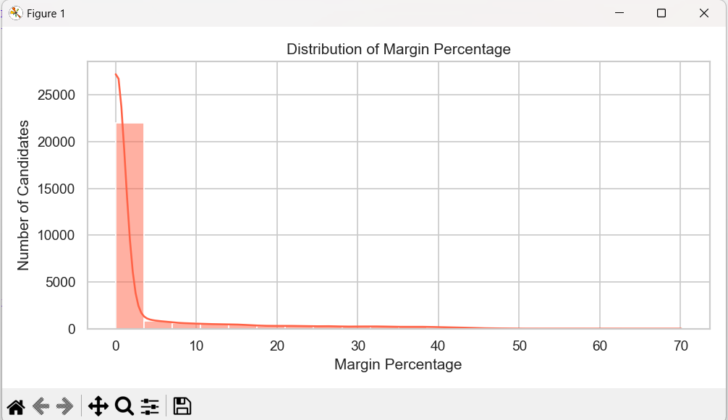

B. Pie Chart – Candidate Gender Proportion
- Introduction: This pie chart shows the proportion of male, female, and unknown-gender candidates.
- General Description: It helps understand gender representation among all candidates.
- Specific Requirements: matplotlib.pyplot.pie() with labels and percentage display.
- Analysis Results: A clear imbalance is seen, with male candidates dominating. Female and unknown categories are significantly lower.
- Visualization: Pastel color palette, with equal aspect ratio for clarity.

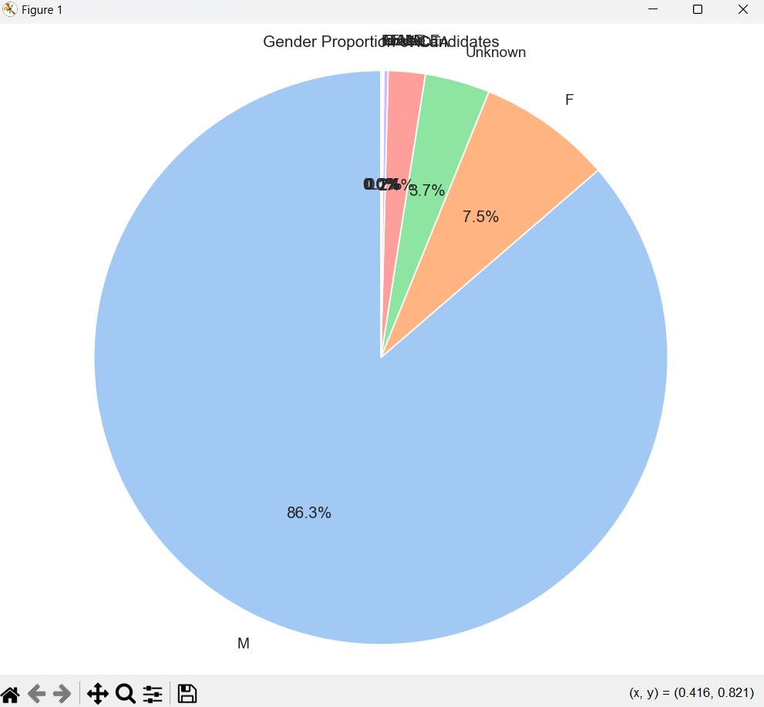

C. Scatter Plot – Valid Votes vs Turnout Percentage by Gender
- Introduction: This scatter plot evaluates the relationship between valid votes and turnout percentage, segmented by gender.
- General Description: It helps identify patterns or clusters, possibly showing gender-based trends.
- Specific Requirements: Used Seaborn’s scatterplot() with gender-based hue.
- Analysis Results: No strong linear correlation; however, patterns suggest male candidates are more often associated with higher valid votes.
- Visualization: Transparent points using alpha=0.7 and distinct color palette.

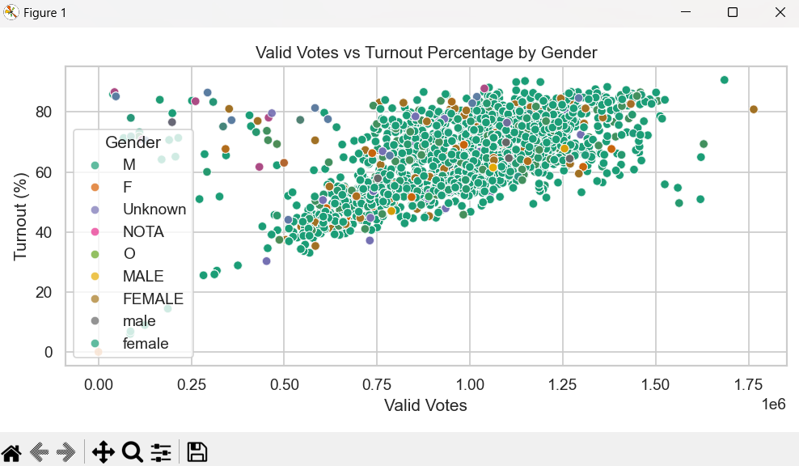

D. Line Plot – Top 10 Candidates by Votes
- Introduction: Displays the top 10 candidates with the highest number of votes.
- General Description: Offers a comparative look at vote concentration among top performers.
- Specific Requirements: Sorted values by vote count, plotted with lineplot() and markers.
- Analysis Results: A steep drop-off is evident from the top candidate downwards, indicating one or two candidates received substantially more support.
- Visualization: Dark blue line plot with rotated candidate names for readability.

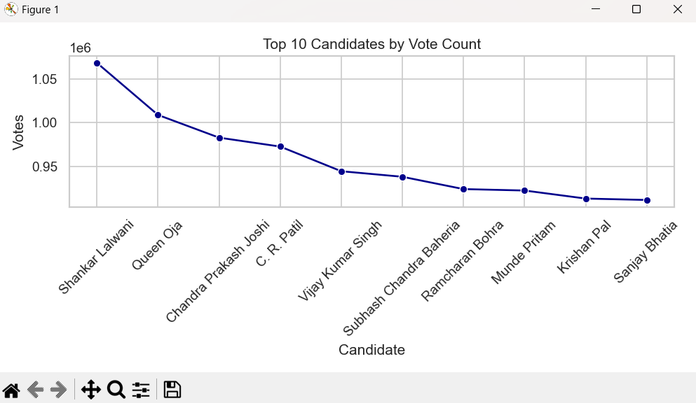

E. Bar Plot – Average Vote Share per Party (Top 10 by Count)
- Introduction: This bar chart represents the average vote share percentage for the 10 most represented parties.
- General Description: Highlights which parties tend to perform better in terms of average vote share.
- Specific Requirements: Grouped by party, calculated mean, sorted and plotted with a horizontal bar.
- Analysis Results: Some lesser-known parties showed surprisingly higher average vote shares, possibly due to regional dominance.
- Visualization: Magma palette with horizontal layout for clarity.

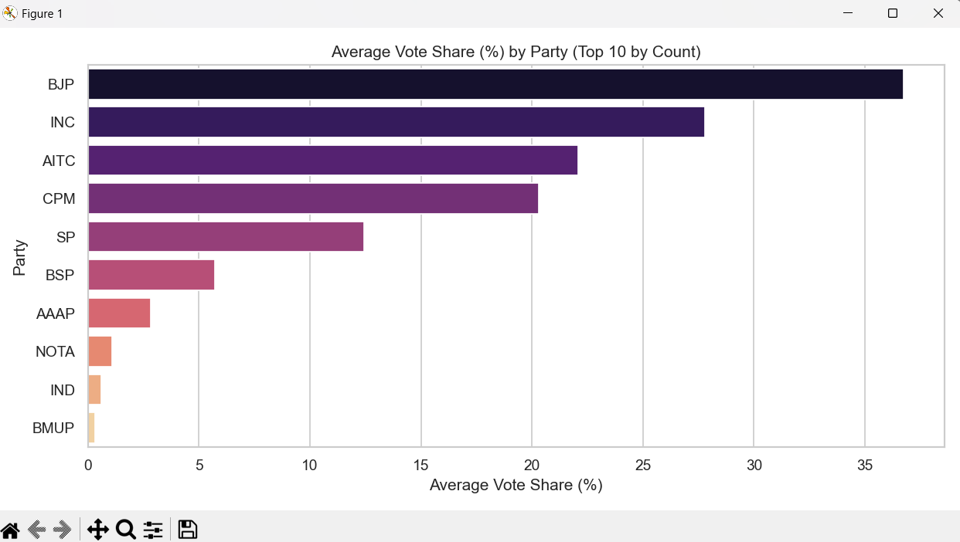

F. Correlation Heatmap – Numeric Features
- Introduction: Heatmap displaying correlations between important numeric election variables.
- General Description: Useful to detect multicollinearity or potential predictive relationships.
- Specific Requirements: Used corr() on numeric columns and seaborn.heatmap().
- Analysis Results: Strong correlations observed between votes and valid votes; moderate correlation with vote share percentage.
- Visualization: Coolwarm palette, annotated with values.

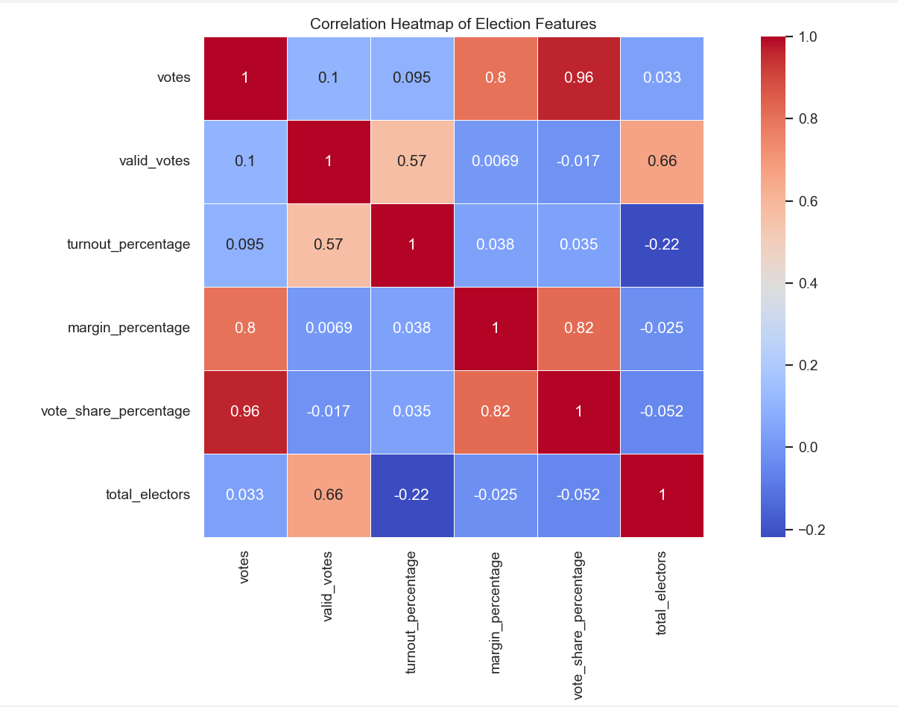

G. Box Plot – Vote Share % by Candidate Type
- Introduction: This box plot breaks down vote share percentage by candidate type.
- General Description: Indicates central tendency and spread across candidate categories.
- Specific Requirements: Grouped by candidate_type, plotted using boxplot() with color-coded hue.
- Analysis Results: Considerable variability exists, with independent or lesser-known candidate types often having lower median vote shares.
- Visualization: Set2 palette, clean and color-separated

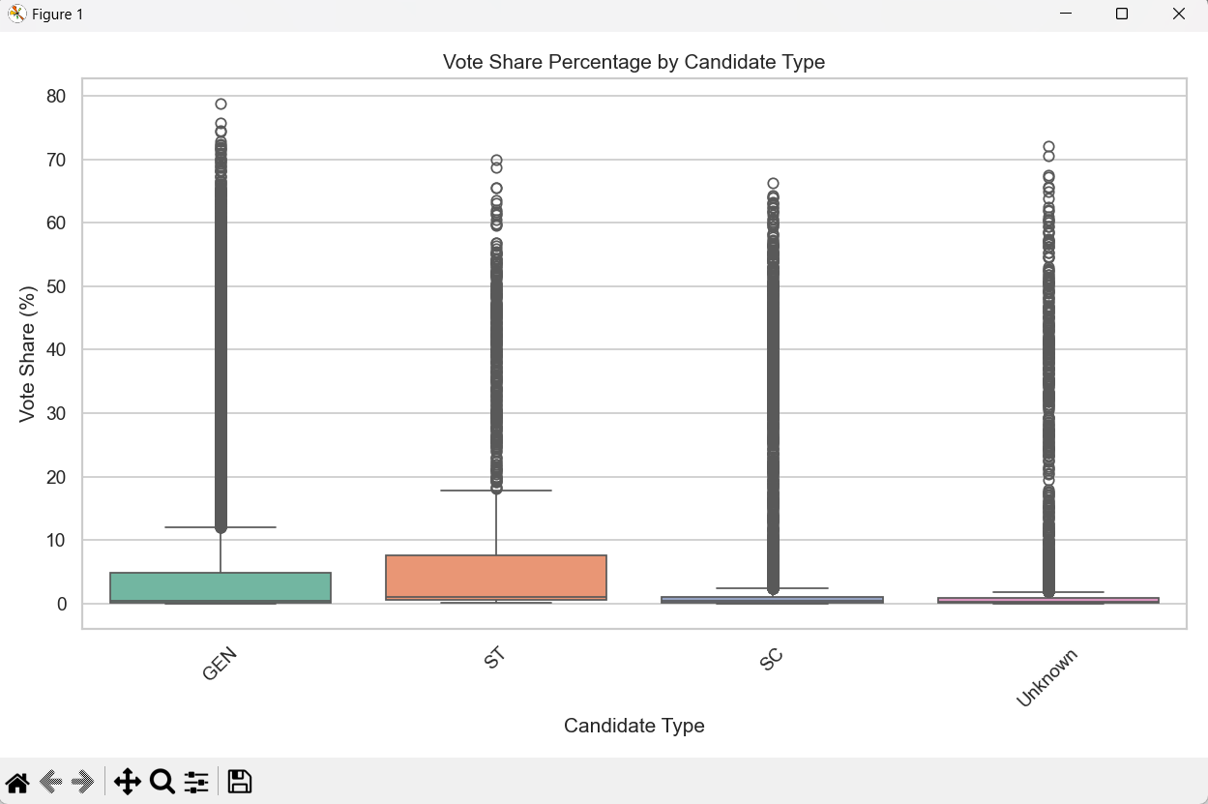

H. Count Plot – Number of Candidates per Party (Top 10)
- Introduction: Shows which parties fielded the most candidates.
- General Description: Reflects political party strategy—volume vs. selectivity.
- Specific Requirements: Used value_counts() to identify top 10 parties, plotted with countplot().
- Analysis Results: A few parties had a significantly larger candidate base, which could skew overall averages.
- Visualization: Crest palette with horizontal bars for easier comparison.

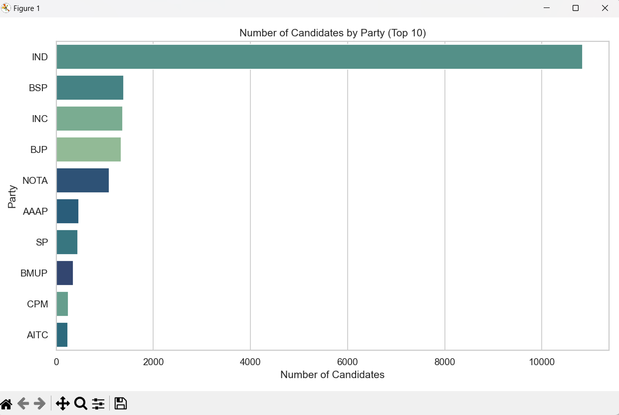

I. Violin Plot – Margin % Distribution by Gender
- Introduction: Shows the distribution of margin percentages across different genders.
- General Description: Combines box plot and KDE to show data spread and density.
- Specific Requirements: Used violinplot() grouped by sex.
- Analysis Results: Males generally had wider spread, but some female candidates had high margins as well.
- Visualization: Viridis color scheme with symmetrical violins.

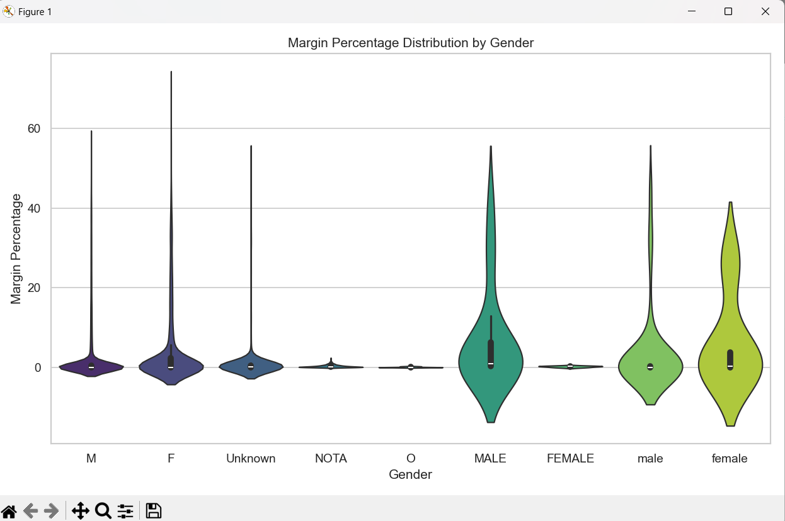

J. Strip Plot – Vote Share % by Gender
- Introduction: This strip plot visualizes individual vote share percentages for each gender.
- General Description: Helps identify clustering or outliers by gender.
- Specific Requirements: Used stripplot() with jitter for visibility.
- Analysis Results: Male candidates cluster around a wide range, while females are more concentrated in mid-range percentages.
- Visualization: Coolwarm palette with jitter and semi-transparent points.

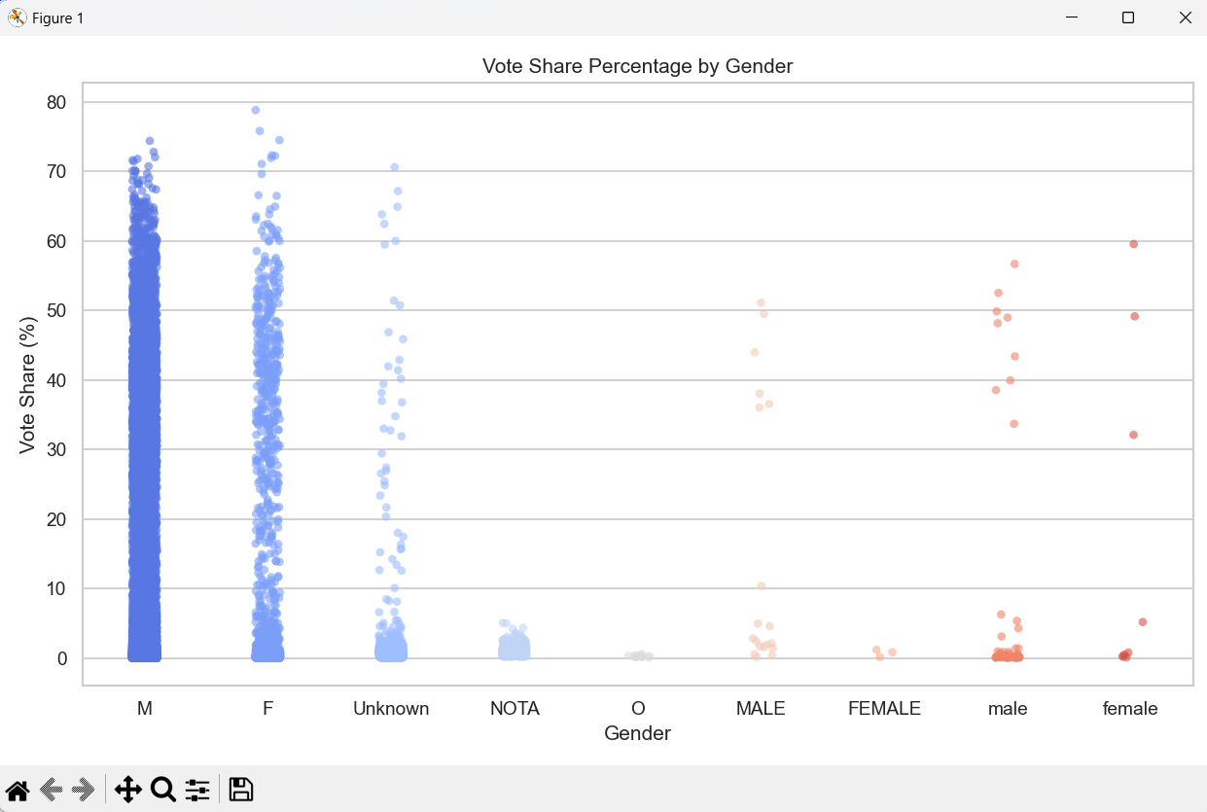

Visualization For all the charts:

- Histogram – Margin Percentage Distribution


2. Pie Chart – Candidate Gender Proportion 

3. Scatter Plot – Valid Votes vs Turnout Percentage by Gender



4. Line Plot – Top 10 Candidates by Votes



5. Bar Plot – Average Vote Share per Party (Top 10 by Count)



6. Correlation Heatmap – Numeric Features


7. Box Plot – Vote Share % by Candidate Type



8. Count Plot – Number of Candidates per Party (Top 10)



9. Violin Plot – Margin % Distribution by Gender



10. Strip Plot – Vote Share % by Gender



5. Conclusion:
The exploratory data analysis (EDA) of the election dataset revealed several key insights into candidate performance, party participation, and voting trends. The visualizations effectively highlighted disparities in vote margins, gender representation, and party influence. The histogram and violin plots showed that most elections were closely contested, with a few large-margin wins. Gender-based analysis uncovered a dominance of male candidates, though performance varied across genders. Party-wise evaluations indicated some smaller parties had high average vote shares despite fewer candidates. Correlation analysis identified strong relationships between valid votes and total votes, which can guide predictive modeling. Additionally, the class imbalance seen in party and gender distributions is an important factor to address in further studies. Together, the variety of chart types—scatter, line, bar, box, and strip plots—offered a multifaceted view of the dataset, making the EDA a strong foundation for future political analysis, model building, or campaign strategy optimization.
6. Future Scope:
This analysis opens up multiple possibilities for future work. Machine learning models could be developed to predict election outcomes based on candidate features like vote share, turnout, and margin. Class imbalances, such as unequal party and gender representation, could be addressed through resampling or weighted algorithms. Feature selection or dimensionality reduction (e.g., PCA) could help simplify predictive models. Interactive tools like dashboards (using Plotly or Streamlit) could make insights accessible to campaign teams or researchers. Further studies could explore candidate success factors by region, analyze independent candidates' viability, or detect anomalies using outlier detection. Integrating this data with demographic or geographic information could provide deeper political insights. Lastly, evaluating candidate types and their impact across different states or elections could enhance strategy development for parties and policymakers alike.

7. References
[1] Election Commission of India, “Statistical Reports of General Elections,” https://eci.gov.in/statistical-report/statistical-reports/, Accessed April 2025.
[2] McKinney, W. (2010). Data Structures for Statistical Computing in Python, Proceedings of the 9th Python in Science Conference.
[3] Hunter, J. D. (2007). Matplotlib: A 2D Graphics Environment, Computing in Science & Engineering, 9(3), 90–95.
[4] Waskom, M. L. (2021). Seaborn: Statistical Data Visualization, Journal of Open Source Software, 6(60), 3021.
[5] Pedregosa, F., Varoquaux, G., Gramfort, A., et al. (2011). Scikit-learn: Machine Learning in Python, Journal of Machine Learning Research, 12, 2825–2830.
[6] Python Software Foundation. Python Language Reference, version 3.10. Available at: https://www.python.org
[7] Pandas Development Team (2020). Pandas: powerful Python data analysis toolkit. https://pandas.pydata.org/

